Q1. Suppose you are developing a bank account management system, and you have defined the
BankAccount class with the required constructors. You need to demonstrate the use of these
constructors in various scenarios.
1. Default Constructor Usage: Create a default-initialized BankAccount object named
account1. Print out the balance of account1.
2. Parameterized Constructor Usage: Create a BankAccount object named account2 with
an initial balance of $1000. Print out the balance of account2.
3. Copy Constructor Usage: Using the account2 you created earlier, create a new
BankAccount object named account3 using the copy constructor. Deduct $200 from
account3 and print out its balance. Also, print out the balance of account2 to ensure it
hasn't been affected by the transaction involving account3.
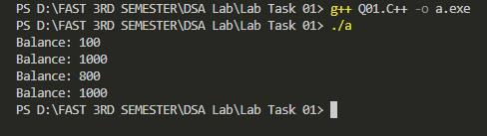

Q2. Create a C++ class named "Exam" using DMA designed to manage student exam records, complete with a shallow copy implementation? Define attributes such as student name, exam date, and score within the class, and include methods to set these attributes and display exam details. As part of this exercise, intentionally omit the implementation of the copy constructor and copy assignment operator. Afterward, create an instance of the "Exam" class, generate a shallow copy, and observe any resulting issues?
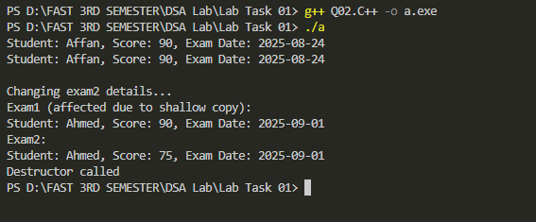

Q3. Create a C++ class Box that uses dynamic memory allocation for an integer. Implement the Rule of Three by defining a destructor, copy constructor, and copy assignment operator. Demonstrate the behavior of both shallow and deep copy using test cases.
